How to access ClassNotes Guide
First go to your Teams general page
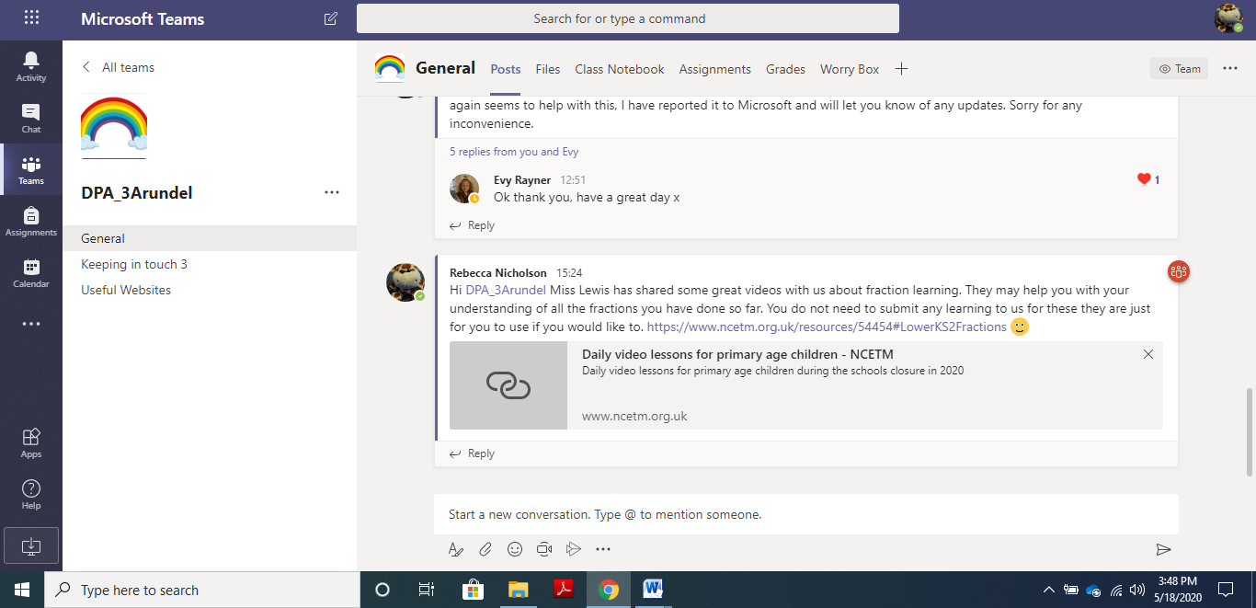
At the top of this page, next to assignments it says Class Notebook. Click this.
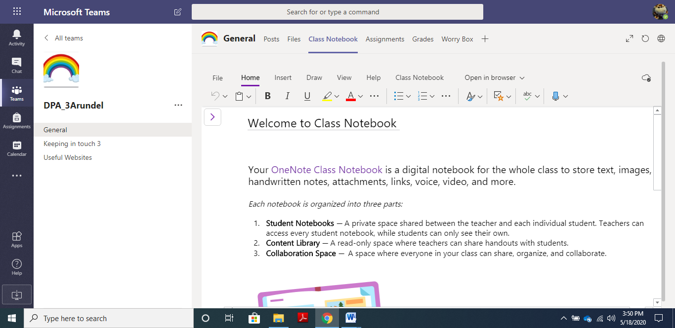
Click this
This will take you to this page – Welcome to Class Notebook. If you scroll down it gives you some informaiton about what a class notebook is.
We will only be using the Colaboration Space at the moment.
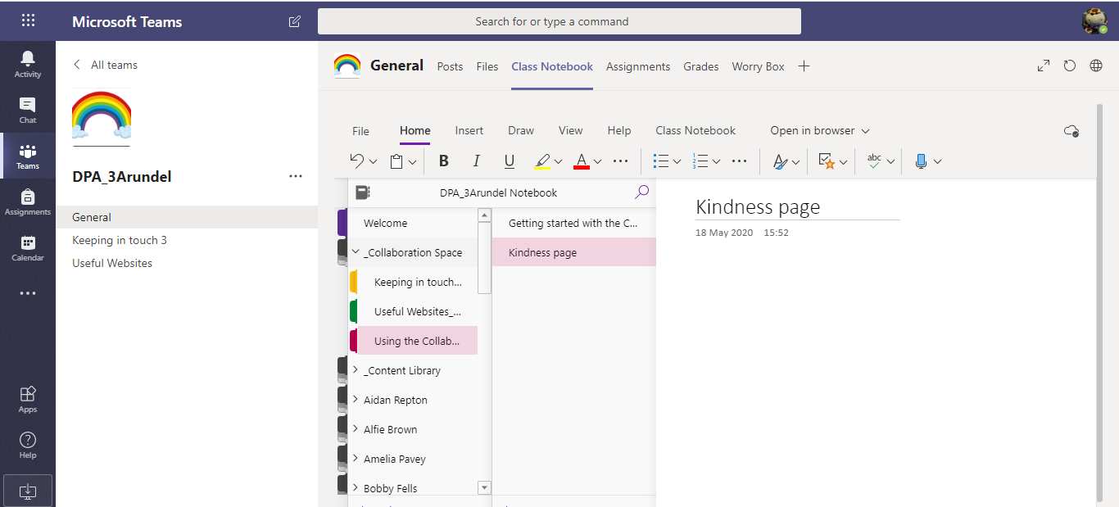
To access the Collaboration Kindness page – click the menu open and go to collaboration space. Go to using collaboration space – underthis will be the Kindness page.
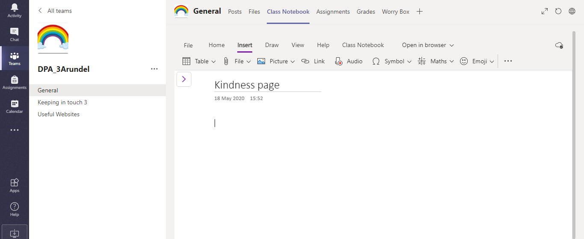
When you are int his page you can add notes, files, links, pictures, voice recordings etc. Teachers will be checking this so please ensure that you are only putting things that are kind and appropriate.

