To see your feedback you will need to go to your completed assignments.
If the assignment has a tick by it will have received feedback,

Click on the assignment to see the feedback,
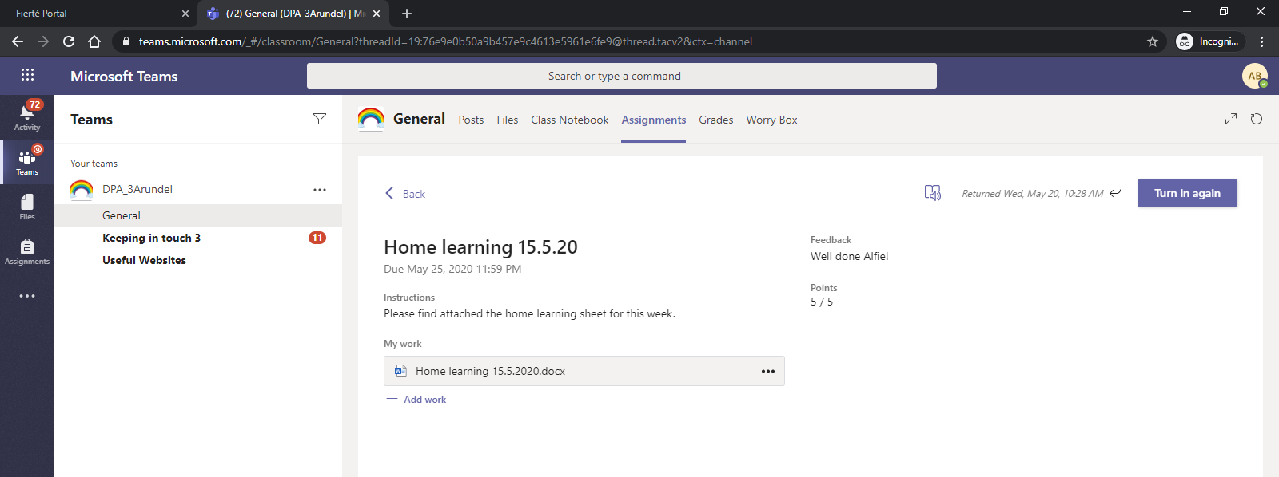
If you want to complete any feedback you can open to document and edit it then turn it in again.

